National University of Computing and Emerging Sciences - CFD Campus



**Computer Networks Spring 2025**

**Assignment # 02**

# Submission Guidelines:

1. Submit your assignment as hardcopy in class as well as in soft copy on Google Classroom. Please submit your file in this format **23F_XXXX_A1**
2. The assignment should be on A4 pages.
3. Do not submit your assignment after the deadline. Late submission will not be accepted.
4. Plagiarism from the internet (ChatGPT) or any peer is strictly prohibited.
5. In case of plagiarism zero marks will be awarded.

**Question # 01. (20)**

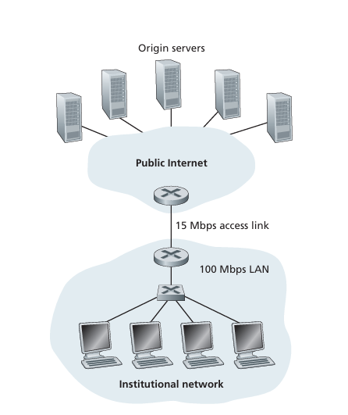

Consider Figure given above, for which there is an institutional network connected to the Internet. Moreover, assume the access link has been upgraded to 54 Mbps, and the institutional LAN is upgraded to 10 Gbps. Suppose that the average object size is 1,600,000 bits and that the average request rate from the institution’s browsers to the origin servers is 24 requests per second. Also suppose that the amount of time it takes from when the router on the Internet side of the access link forwards an HTTP request until it receives the response is three seconds on average. Model the total average response time as the sum of the average access delay (that is, the delay from Internet router to institution router) and the average Internet delay. For the average access delay, use ∆/(1- ∆b), where ∆ is the average time required to send an object over the access link and b is the arrival rate of objects to the access link.

1. Find the total average response time.
2. Now suppose a cache is installed in the institutional LAN. Suppose the miss rate is 0.3. Find the total response time.

**Question # 02. (5)**

Describe differences between SMTP (Simple Transfer Protocol) and IMAP (Internet Message Protocol). Explain how they work together in the context of email communication.

**Question # 03. (20)**

Consider a short, 10m link, over which a sender can transmit at a rate of 150 bits/sec in both directions. Suppose that packets containing data are 100,000 bits long, and packets containing only control (e.g., ACK or handshaking) are 200 bits long. Assume that N parallel connections each get 1/N of the link bandwidth. Now consider the HTTP protocol, and suppose that each downloaded object is 100K bits long, and that the initial downloaded object contains 10 referenced objects from the same sender. Answer the following:

1. Calculate the time it takes to download all the objects via parallel non-persistent HTTP instances.
2. Calculate the time it takes to download all the objects via parallel persistent HTTP
3. Calculate the time it takes to download all the objects via non-parallel persistent HTTP.
4. Would parallel downloads via parallel instances of non-persistent HTTP make sense in this case? Justify your choice.
5. Do you expect significant gains from non-persistent parallel HTTP connections over the non-parallel persistent case? Justify.

**Question # 04. (10)**

Suppose a client wants to download a webpage that consists of an HTML file and 5 embedded objects (such as images and CSS files). Each object is 10,000 bits in size, and the HTML file is 15,000 bits. The round-trip time (RTT) between the client and the server is 100 milliseconds. Assume that the server processes the request and sends the response immediately. The transmission time for each object is negligible.

1. How long does it take to download the entire page using **non-persistent HTTP**?
2. How long does it take to download the entire page using **persistent HTTP**?

**Question # 05. (10)**

# Case Study:

StreamLive, a global video streaming platform, aimed to provide a seamless and high-quality user experience to millions of users by designing an efficient network application. The platform relied on a client-server model, where users could access video content by sending requests to the platform’s servers. To meet the demands of video streaming, StreamLive optimized the use of transport services by selecting protocols based on the content being delivered. For real-time video, they utilized UDP to minimize latency, while more critical data like webpage content relied on TCP for reliability.

In addition, StreamLive enhanced its web performance through the use of persistent HTTP connections, which reduced the overhead of establishing new connections for each user request. By integrating web caching, they were able to serve frequently requested content faster, reducing server load and improving response times for users. Cookies were also employed to manage user sessions and personalize content, creating a more tailored experience for individual users. Through this combination of technologies, StreamLive was able to ensure both high performance and user satisfaction on a global scale.

1. Why did StreamLive choose a client-server architecture for their video streaming platform, and how does this model ensure efficient communication between users and the server?
2. How does StreamLive differentiate between the use of TCP and UDP for delivering different types of content, and why is UDP preferred for real-time video streaming?
3. What are the advantages of using persistent HTTP connections in StreamLive's platform, and how do they contribute to reducing latency and improving user experience?
4. How does StreamLive's implementation of web caching enhance the performance of their platform, and in what ways does it reduce the load on their servers?
5. In what ways does StreamLive use cookies to manage user sessions and personalize content, and how does this balance performance improvements with user privacy concerns?

**Good Luck 😊**